8D7N YANGON–BAGAN–MANDALAY–INLE–YANGON
DAY 1: YANGON ARRIVAL – CITY SIGHTSEEING ( -/L/D )
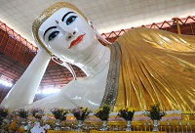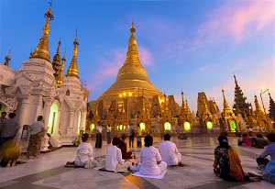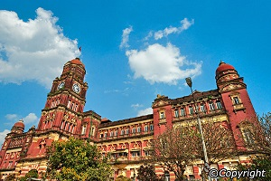
Chauk Htat Gyi pagoda Shwedagon Pagoda Yangon high court building

Upon your airport arrival, you will be greeted and welcomed by our guide and driver and then transferred to your hotel. After check in at your hotel and receive a brief freshening up before begin your city tour with us.Heading to YANGON’S COLONIAL part, soon you realize Yangon is a unique city, unlike any other of its size in all of Southeast Asia. It is Myanmar's commercial capital with a population of more than five millions. Take a walking tour to get a sense of Yangon's beauty with its picturesque lakes, verdant parks as well as its charming people. Next, you are about to see the highlighted destinations of Yangon. It all starts with a visit to CHAUKHTATGYI TEMPLE which holds the biggest reclining Buddha statue in Southeast Asia. Afterwards, wander around Sule Pagoda which is Myanmar's oldest pagoda of 2,500 years old. During the day, you attention might be caught by the spectacular image of SHWEDAGON POGODA - patient, let's save the best for the last. When the sun sets, you will experience the wonder of this inspiring pagoda, being left breathless with its vivid color and sacred atmosphere. After a long day, take a good night sleep at your hotel in YANGON.

Meals: 1 Lunch + 1 Dinner
Accommodation: Overnight in Yangon.
The distance: Yangon International Airport – Yangon Capital : 15 km – 40 minutes for transfer.

DAY 2: YANGON – BAGAN SIGHTSEEING ( B/L/D)
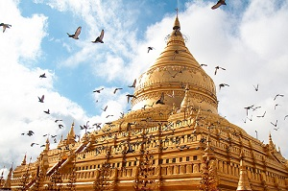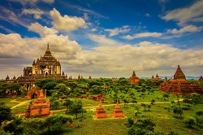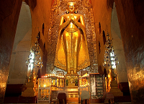
Shwezigon Pagoda Bagan panorama Ananda temple

After having breakfast, you will be transferred to the airport for a domestic flight to Nyaung U. As you arrive, we will drive you to your hotel in Bagan to check in. After that, discover Bagan - the land of thousands antiquated pagodas, one after another among green bushes. Start our trip by visiting SHWEZIGON PAGODA, the first gold pagoda built in Burma enshrining Gautama Buddha's relics and ANANDA TEMPLE, the home of four huge Buddha standing statues - each faces one of the four cardinal directions. Afterward, more temple visitations are carried out as we take you to GUBYAUKGYI TEMPLE at Myinkaba - an Indian style pagoda built in 1113 whose exteriors are still in good condition, HTILOMINLO TEMPLE whose name means "blessings of the three worlds" containing four Buddha images facing four directions on its first floor, and SULAMANI TEMPLE - a Buddhist edifice rebuilt in 1994 from which Htilominlo Temple was built after. Dinner & overnight at BAGAN.

Meals: 1 Breakfast + 1 Lunch + 1 Dinner
Accommodation: Overnight in Bagan.
The distance: Yangon city - Yangon Airport: 15 km – 40 minutes for transfer
Nyaung U Airport – Hotel : 8 km – 15 minutes for transfer

DAY 3: BAGAN SIGHTSEEING (B/L/D)
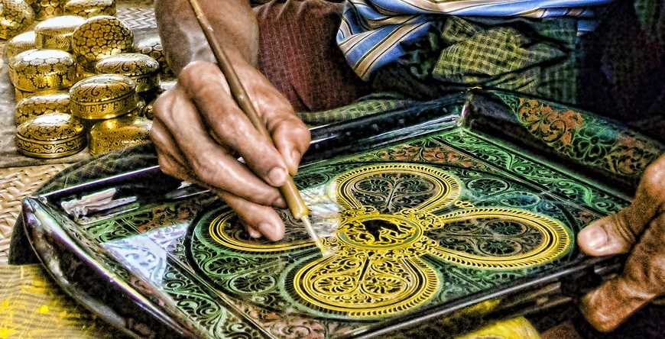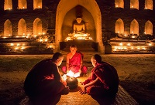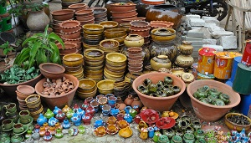
Laquer Ware Workshop Monks in Bagan Nyaung U market

In the morning, head to Nyaung U Market where local products are boisterously bought and sold - you can get some real bargains there as souvenirs. In the afternoon, come to LACQUER WARE WOKSHOP to observe what they are made of. Next, visit DHAMMAYAZIKA, a five-sided pagoda complex where in each side there is a small temple housing a Buddha statue. As the sun is about to set, sail down the Ayeyarwaddy River to reach KYAUK GU U MIN, a cave temple with excellent sandstone carvings and giant Buddha images. Splendid natural settings blend perfectly with antique humans' construction, surely an ideal place to enjoy dusk. Enjoy the dinner at local resturants .Overnight in BAGAN.

Meals: 1 Breakfast + 1 Lunch + 1 Dinner
Accommodation: Overnight in Bagan

DAY 4: BAGAN – MANDALAY – SAGAING SIGHTSEEING (B/L/D)
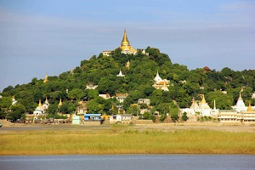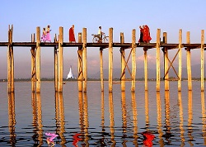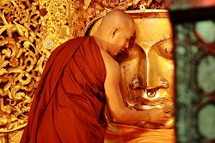
Sagaing hill U bein bridge Mahamuni Buddha Temple

After having breakfast, you will be transferred to Nyaung U Airport for a domestic flight to Mandalay, the last capital of the Myanmar Kingdom before the 1885 Britain's annexation and also the heart of Burmese culture. Upon arrival, leave the city and head to Sagaing, an important religious center of Myanmar thanks to its numerous Buddhist monasteries. There, access U MIN THONZE CAVE TEMPLE with its impressive Buddha statues and SOON U PONYA SHIN PAGODA, Sagaing's central pagoda located at the top Pagaing Hill, offering you the enjoyment of seeing Mandalay's panoramic view.Next, take a half hour drive to Amarapura, the best place to experience the monk life in Mandalay and access its famous Mahagandayon Monastery - one of the largest monasteries in Burma. As you walk over U BEIN BRIDGE - the world's most extended teak bridge, head to Mahamuni Buddha Temple to see Mahamuni Image - a bronze Buddha statue originally from Rakhine State. Being made during the Buddha's own lifetime, the image is considered a representation his life. Stay overnight in Mandalay.

Meals: 1 Breakfast + 1 Lunch + 1 Dinner
Accommodation: Overnight in Bgan
The distance: Bagan - Nyaung U Airport: 8 km – 15 minutes for transfer
Mandalay Airport – Hotel: 35 km – 50 minutes for transfer

DAY 5: MANDALAY – MINGUN – CITY SIGHTSEEING (B/L/D)
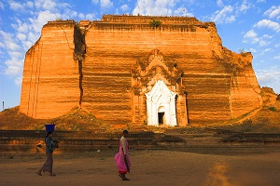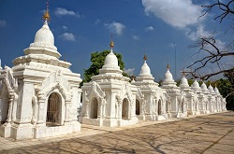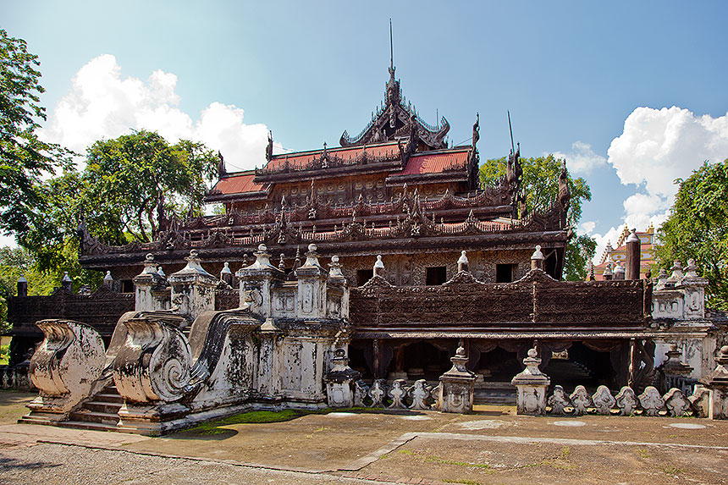
Mingun temple Kuthodaw Pagoda Shwenandaw Monastery

This morning we will be driven to Mandalay pier, and then embarked on a private boat upstream to Mingun. Our first stop in Mingun is the world’s largest unfinished PAHTOTAWGYI PAGODA. The pagoda’s lower terraces feature slabs of marble bearing depictions of important scences from the Jataka, literary works concerning the pervious lives of the Buddha. Inside the temple, you can see an inscription stone that details the history of the temple’s construction. Leave the pogoda, we will lead in MINGUN BELL which has a weight of 90 tons After lunch break, we continue our journey to Mandalay Palace, SHWENANDAW MONASTERY and a gold leaf beating workshop. We also go to KUTHODAW PAGODA which houses the world’s largest book stand upright, setting in stone in the grounds. At dusk, if weather is fine, it would be an interesting end for the fifth sightseeing day if we climbup to the Mandalay Hill to enjoy the beautiful sunset and panorama of the city behind. Overnight in Mandalay.
.

Meals: 1 Breakfast + 1 Lunch + 1 Dinner
Accommodation: Overnight in Mandalay
The distance: Hotel in Mandalay – Mingun: 30 km – 1hour & 20 minutes for transfer

DAY 6: MANDALAY – INLE LAKE SIGHTSEEING (B/L/D)
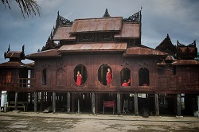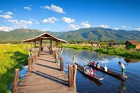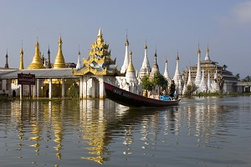
Shwe Yan Pyay Monastery Inle lake Stupa on lake

In the early morning, you will be transferred to the airport for the fight to Heho, the primary air gateway to Inle Lake. It takes one hour to drive from Heho to Inle; along the way, soothe yourself with cool weather and peaceful settings. Drop by a Shan paer umbrella workshop to how skillful locals are to create these amazing handicrafts. Also, visit SHWE YAN PYAY MONASTERY which was constructed completrly from teak and painted red. Now you are at Inle Lake, one of the most renowed destinations of Myanmar. Take a boat to visit Inle Lake. On the surface of the lake, you can see floating villages, floating gardens, floation markets, serveral traditional villages such as weaving. The most special sight on Inle Lake is floating gardens where the local use the water hyacinth combining with seaweed on the bottom of the lake to keep the oild to grow vegetables such as tomatoes, mint, etc. Up and down the lake have many temples, monasteries with golden pinnacles brightening on the sunlight. Discover PHAUNG DAW OO PAGODA where houses the five Buddha images. These images are covered with gold in order to make visitors not be able to see the original form. Leave PHAUNG DAW OO PAGODA, we continue to YWA MA VILLAGE and KAY LAR VILLAGE before move to your hotel and check in. Stay overnight in Inle/ Nyaung Shwe.

Meals: 1 Breakfast + 1 Lunch + 1 Dinner
Accommodation: Overnight in Inle/Nyaung Shwe
The distance: Hotel - Mandalay Airport: 35 km – 50 minutes for transfer
Heho Airport – Nyaung Shwe/ Inle: 30 km – 40 minutes for transfer

DAY 7: INLE – INDEIN TEMPLE - YANGON (B/L/D)
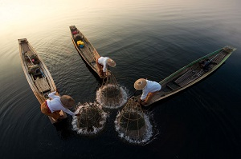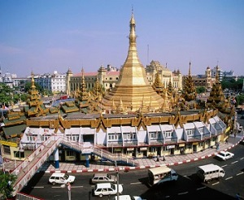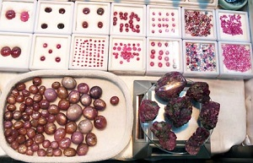
The Leg-Rowing Intha Fisherman Sule pagoda Ruby shop

In order not to miss a great opportunity to enjoy the scene of local tribes in their colorful clothes and exotic market atmosphere, in the early morning, we will take a boat to the lake and visit THE LOCAL MARKET which is held every five day. Then we will move by boat to Indeinn to witness the farmers havesting their crops and rarely-known site of Indein which still remains hundreds of ancient brick stupas and pagodas dated back to 17 century the ancient SHWEINNDEIN PAGODA. In the late afternoon transfer to airport for a flight to Yangon.
Shopping to Bogyoke or Scott Market, a famous shopping center to enjoy display of Myanmar handicraft and Gems Shops & enjoy walking tour from Sule Pagoda & visit to the Maharbandoola Park, 48 meters golden dome explore a great city and this tour takes in the best of Myanmar Heritage Building in Yangon.
Overnight in Yangon.

Meals: 1 Breakfast + 1 Lunch + 1 Dinner
Accommodation: Overnight in Yangon
The distance: Nyaung Shwe/ Inle - Heho Airport: 30 km – 40 minutes for transfer
Yangon International Airport – Yangon: 15 km – 40 minutes for transfer

DAY 8: YANGON - DEPARTURE (B)
Free time until transfer to Yangon International Airport for your departure flight.

Meals: 1 Breakfast
The distance: Hotel - Yangon International Airport: 15 km – 40 minutes for transfer

The ends of program!
SEQUENCE OF ITINERARY SUBJECT TO LOCAL ARRANGEMENT
PRICE INCLUDE:
Accommodation – as hotel in the list or similar – based on Twin/Double/Triple sharing
- Tour guide: English speaking guide during the tour.
- Shows and sightseeing in schedule.
- Transportation by private air-conditioner.
- Boat trips mentioned
- 01 bottle (500 ml) of drinking water for each pax per day.
- Meals (Burmese Food & Chinese Food) as the tour code ( B: Breakfast, L: lunch, D: Dinner)
- Domestic flights tickets
PRICE EXCLUDE:
- International & airport tax
- Camera fee
- Personal expenses: Tel, Fax, Mini Bar, Laundry,etc.
- Personal travel insurance
- Compulsory Tip for local guide and driver (USD/PAX/DAY)

Group Size | Tips in USD
2 – 4pax | 6
5-7pax | 5
8 - up | 3

- Surcharge with other languages guide.
- Surcharge at hotel case by case
  - Burmese New Year (TBA)
  - Gala Dinner on X’Mas (24 Dec ) & New Year 31 Dec

Hotel listed or Similar | All rates are next in USD/pax  valid for LOW SEASON from 01 May 19 to 30 Sep 2020
Hotel listed or Similar | Tour by private car / bus with private guide
 | 2 | 3-4 | 5-6 | 7-9 | 10-12 | 13-15 | 15+1 | 20+1 | 25 +1 | 30+1 | SGL SUP
3* | 1180 | 1060 | 960 | 910 | 865 | 850 | 850 | 835 | 820 | 805 | 195
4* | 1245 | 1125 | 1030 | 975 | 930 | 920 | 925 | 905 | 890 | 875 | 265
5* | 1415 | 1295 | 1195 | 1145 | 1095 | 1090 | 1095 | 1075 | 1060 | 1045 | 435

Hotel listed or Similar | All rates are next in USD/pax  valid for HIGH SEASON from 01 Oct 18 to 10 Apr 19
Hotel listed or Similar | Tour by private car / bus with private guide
 | 2 | 3-4 | 5-6 | 7-9 | 10-12 | 13-15 | 15+1 | 20+1 | 25 +1 | 30+1 | SGL SUP
3* | 1225 | 1105 | 1005 | 955 | 930 | 895 | 895 | 875 | 860 | 850 | 240
4* | 1315 | 1195 | 1095 | 1045 | 1020 | 985 | 990 | 970 | 955 | 945 | 330
5* | 1640 | 1520 | 1420 | 1370 | 1345 | 1310 | 1320 | 1300 | 1285 | 1270 | 655

 | 3* | 4* | 5*
YANGON | Grand United Ahlone 3*  Grand United China Town 3*  Grand United donwntown 3* | Taw Win Garden 4* | Park Royal 5*  Chatrium 5*
BAGAN | Yadanarbon Bagan 3*  The Regency 3* | Amazing Bagan 4*  Treasure 4*  Thiripyitysaya Sanctuary 4* | Bagan Lodge 5*  Aureum Palace 5*
MANDALAY | Hotel Mandalay 3*  Mandalay City 3*  Yadanarbon Dynasty 3* | Hazel 4* | Mandalay Hill 5*
INLE | Royal Inle 3*  Paradise Nyang Shwe 3*  Grand Nyaung Shwe 3* | Paramount Inle 4*  Novotel Inle 4*  Inle Resort & Spa 4* | Sofitel Inle lake 5*

NOTE

The timing of sightseeing points shall be fixing by local operator due to traffic and weather conditions, however all points must cover unless amendment or cancellation make by clients themselves (Non-refundable for any cancellation that made by clients)

Tour and price are subject to change without notice or incase of deduct number of pax in quoted group.

Small deviations in the tour program are sometimes necessary, depending on weather, road conditions, flight schedules and room availability.

Supplement charge for room rate in peak dates depends on the hotel category used. Compulsory gala dinner on X’mas, New Year’s Eve to be advised upon booking. Prices for group of 15 persons up in 5 stars hotels sometime requires to re-quote bases on the hotel policy

Group tour 20pax, you will get 01 FOC for tour leader based on twin sharing basis include breakfast (domestic air ticket is not applicable)

BUS

Group Size | Kind of Transportation
1-2 pax | 4 seater
3 pax | 7 seater
4-9pax | 16 seater
10-18 pax | 30 seater
19-21 pax | 35 seater
22 – 42 pax | 45 seater

CHILD POLICY

- Infant below 2 years old sharing same room with parents is free of charge.
- Child below 12 yrs old sharing same room with 1 ADL is charged for 90%.
- Child below 12 yrs old with extra bed and sharing same room with parents is charged for 65%.
- Child below 12 yrs old No extra bed & sharing same room with parents is charged for 55%.

TERM & CONDITIONS

1. CANCELLATION
In case of cancellation, fees will be charged accordingly to the day that official notice in writing is received at Hanoi Office: No 11, lane 8, Doi nhan, Ba Dinh district, Hanoi-Vietnam.

- Before 30 days: No charge
- Less than 30 days: 50% of total tour price
- Less than 14 days: 75% of total tour price
- Less than 7 days before arrival date or no-show: 100% of total tour price

Any cancellation due to irresistible reasons such as wars, strikes, earthquakes, etc. will be considered subject to each case.

